SELECT c.id Nro, c.company Empresa, od.unit_price Monto,

CASE WHEN p.category = 'Condiments' THEN od.unit_price ELSE 0 END MontoCondiments,

CASE WHEN p.category = 'Sauces' THEN od.unit_price ELSE 0 END MontoSauces,

CASE WHEN p.category = 'Beverages' THEN od.unit_price ELSE 0 END MontoBeverages

FROM customers c

INNER JOIN orders o ON c.id = o.customer_id

INNER JOIN order_details od ON o.id = order_id

INNER JOIN products p ON od.id = p.id

WHERE p.category = 'Condiments' OR p.category = 'Sauces' OR p.category = 'Beverages'

order by od.quantity desc

LIMIT 10;

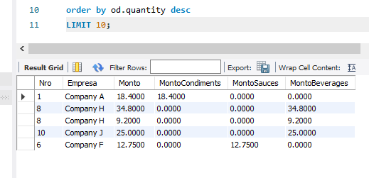

Freire Joaquín